Testimonial Research Semester at Shibaura Institute of Technology

Bojan Lukic
Clausthal 2022

Inhalt
Communication and Preparation for the Research Semester 3
(Scientific) Communities at SIT 4
Research Project 6
Conclusion 7

Communication and Preparation for the Research Semester

The idea for the research semester at Shibaura Institute of Technology (SIT) came during my communciation with the International Center in Clausthal. I was looking for an opportunity to do some project which could benefit me during my work on the master’s thesis. I quickly found out via Mr. Heidemann that there is an opportunity to do projects and research at universities in Asia. After reading reviews about the university and doing my own research, I quickly decided to do the research project at SIT. Due to the pandemic, I did not have the chance to go to Japan and therefore had to conduct the research project online.
The application process for the admission at SIT was quite complex and I had to read a lot of guidelines and complementary resources to understand when, where, and how I needed to apply for the project. The writing of all necessary documents itself was quite straightforward and I received quick feedback from SIT. For the application, the student has three choices for professors he/she wants to study with during the research project and needs to write one application (one page) for each professor. In my case, I received a positive answer for the professor which was my first choice.
My professor, Masaomi Kimura, is affiliated to computer science and engineering and the head of the Data Science/Engineering Laboratory. I decided to work with him due to our overlapping interests in data science, machine learning, and in general computer science. The communication with the professor was very easy and straightforward. First, we communicated via email, but quickly switched to Slack, which is predominantly used at SIT and by the learning groups at the SIT.
After the start of the research semester, there was no need for further communication with the university itself and all necessary communication was done with professor Kimura. I did not have further contact with other professors/students at the SIT or the learning groups which I see as a direct result from the online studies and not being physically present at the university. The communication with both the staff at SIT and professor Kimura was always commendable and respectful. All parties were helpful and responded quickly.

(Scientific) Communities at SIT

As shortly mentioned in the previous section, professor Kimura is the head of the Data Science/Engineering Laboratory and guides learning groups on Slack. The learning group that I was part of is the Data Engineering Laboratory 2022. This group is dedicated to all students and researchers who are part of professor Kimura’s laboratory and who work on different projects. Unfortunately, I did not have a lot of contact with other members, which I see as a result from conducting the research semester online and not seeing the people in person. The communication with professor Kimura was also done with Slack, using private messages.
There was information about communities affiliated with the SIT which are active on social media and in private, which I did not pursue further. Figure 1 and 2 show screenshots of the starting room and the group of professor Kimura on Slack.
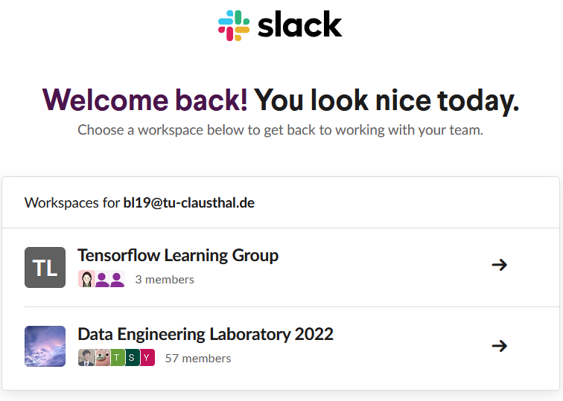
Figure 1 - Starting room in Slack

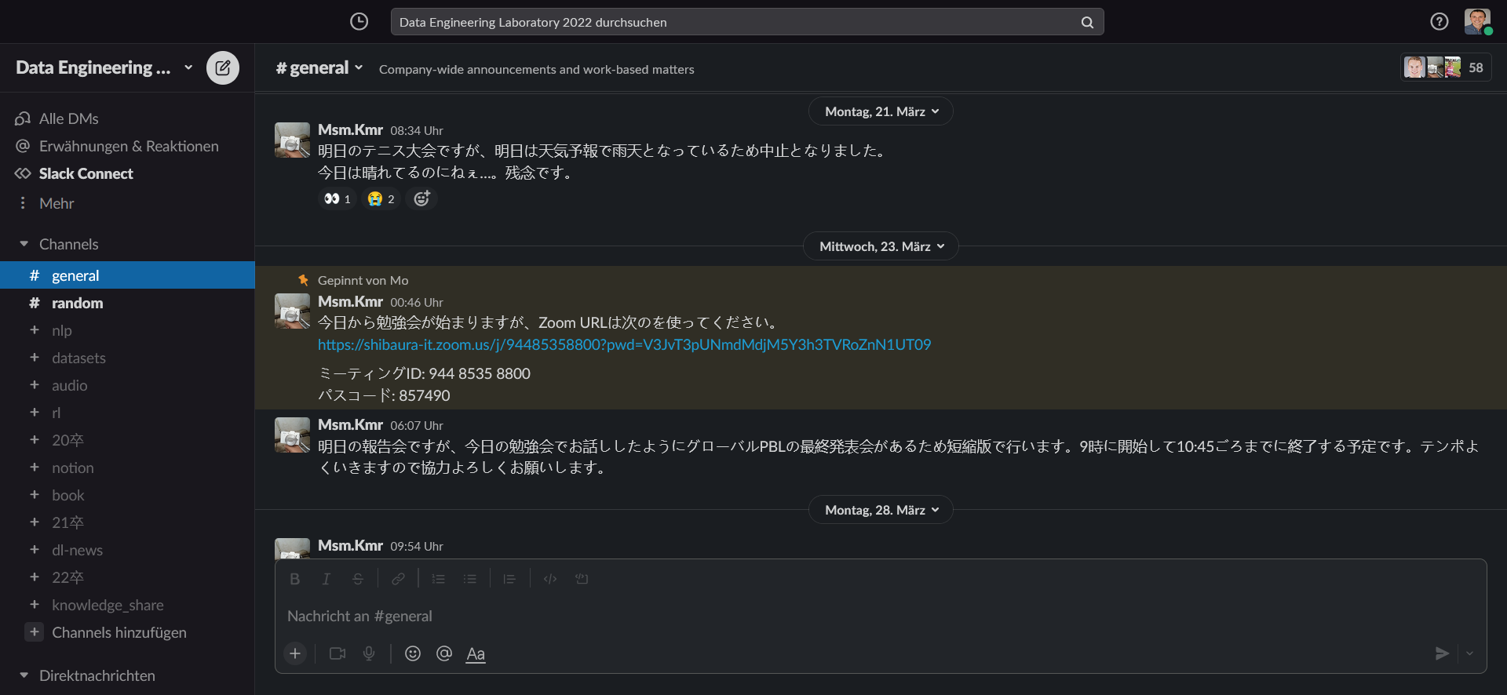
Figure 2 - Data Science laboratory on Slack

Research Project

I was meeting professor Kimura on a wekly and sometimes bi-weekly basis. We had our first meeting in the beginning of January 2022 and the last at the end of March 2022. For each meeting I had to prepare (or rather update) a report which gave an overview on the achievements I made in the week and the status of the project. This report helped me keep track of my achievements and the milestones defined for the project. An exemplary report is shown in the following attachment:
The project itself was about the evaluation of machine learning models with error metrics and involved some statistics and computer science. The models used come from the domains of machine learning, statistics, and data analysis. The goal of the project was to create a program which could create synthetic multivariate time series from some input data, perform forecasts on the new data with machine learning models and quantify the quality of the machine learning models with metrics in an unsupervised manner. With the guidance of professor Kimura and some thorough research I managed to finish the project in the defined time frame. The project was concluded with a research paper, this paper is presented in the following attachment:
The meeting dates with professor Kimura were agreed upon on a weekly basis without any complications. Professor Kimura was very flexible when it came to finding fitting dates, even with the big time difference between Japanese Standard Time (JST) and European Central Time (ECT). Being part of the laboratory and working with professor Kimura was a lot of fun and very informative. I have excelled in the field of machine learning, benchmarking, and statistics with this project. Even though the project duration was quite short (three months) the project felt at no point in time rushed or stressful.

Conclusion

The research semester at SIT was most likely the best experience I could have had in the last semester of my master’s study. Since I did not have any more exams in that semester and a conventional semester abroad (including examinations and credit points to be achieved) would not have worked, the research semester at SIT provided the best solution in my situation. Professor Kimura, other students, and the staff of the SIT were all very kind and helpful. Thanks to the project I always had a neat side project which I could turn to whenever I had a break from my master’s thesis. I would like to thank Mr. Heidemann for the quick recommendation, professor Kimura for the interesting meetings and helpful guidance, and the SIT for making the research semester possible in the first place.
If there are any more questions about the research semester and my experiencce, I would love to answer them privately.

